**Files and Directories**

**Basic Linux Commands:**

* whoami = To check Who you’re logged n as

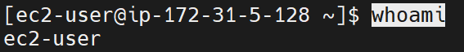

* who/w = Displays who is online

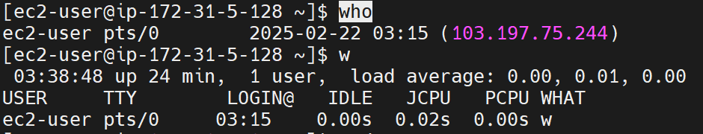

* sudo su - = Switch to root user

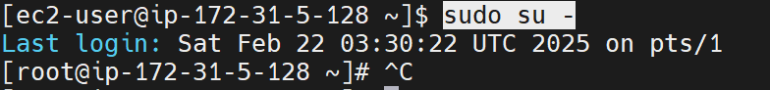

* date = Show the current date and time



* cal = Show this month’s calendar

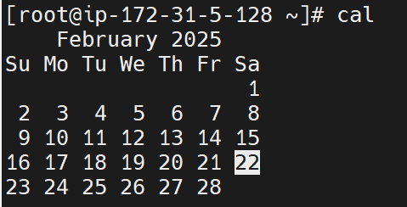

* uptime = Show current uptime



* users = Show user information:



* man <command> = Shows manual of command (man cal)

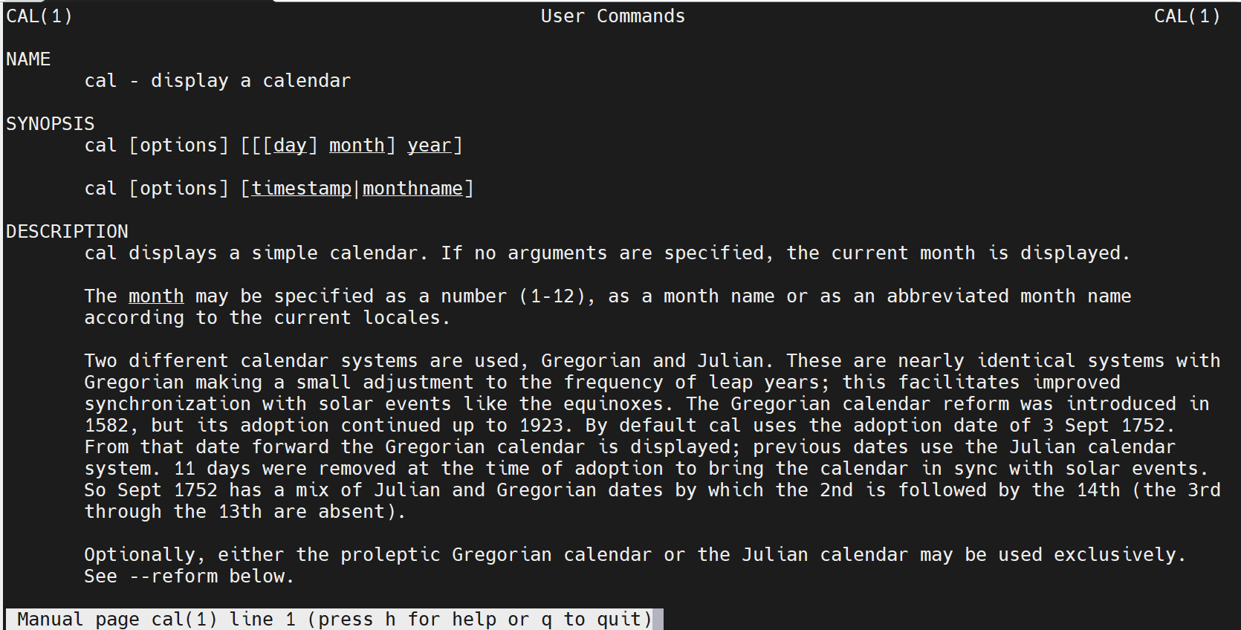

* pwd = To see present working directory



* cd <directoryname> = change directory

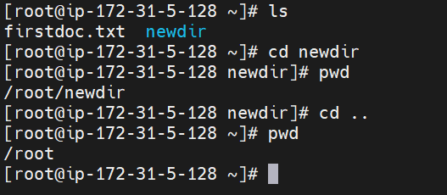

* clear = Clear the screen



**View files(Open/Read):**

* ls = List out all the files in present working directory

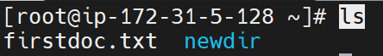

* cat <filename> = display contents of a filename (directly displays end of the file)



* less <filename> = Displays content of the file page by page (space to switch to next page, q to quit from file)

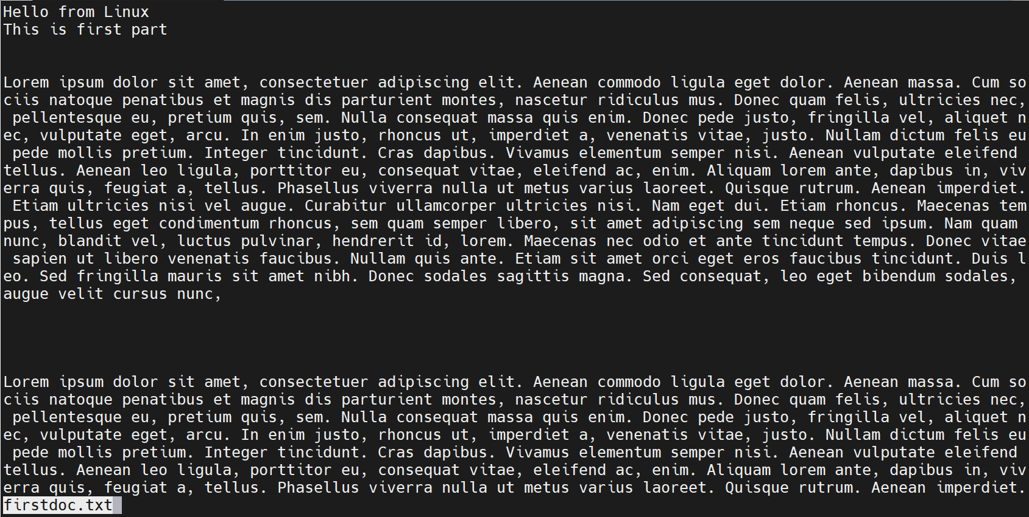

* more <filename> = works in similar way as less but displays content of the file in percentage (space to switch to next page, q to quit from file)

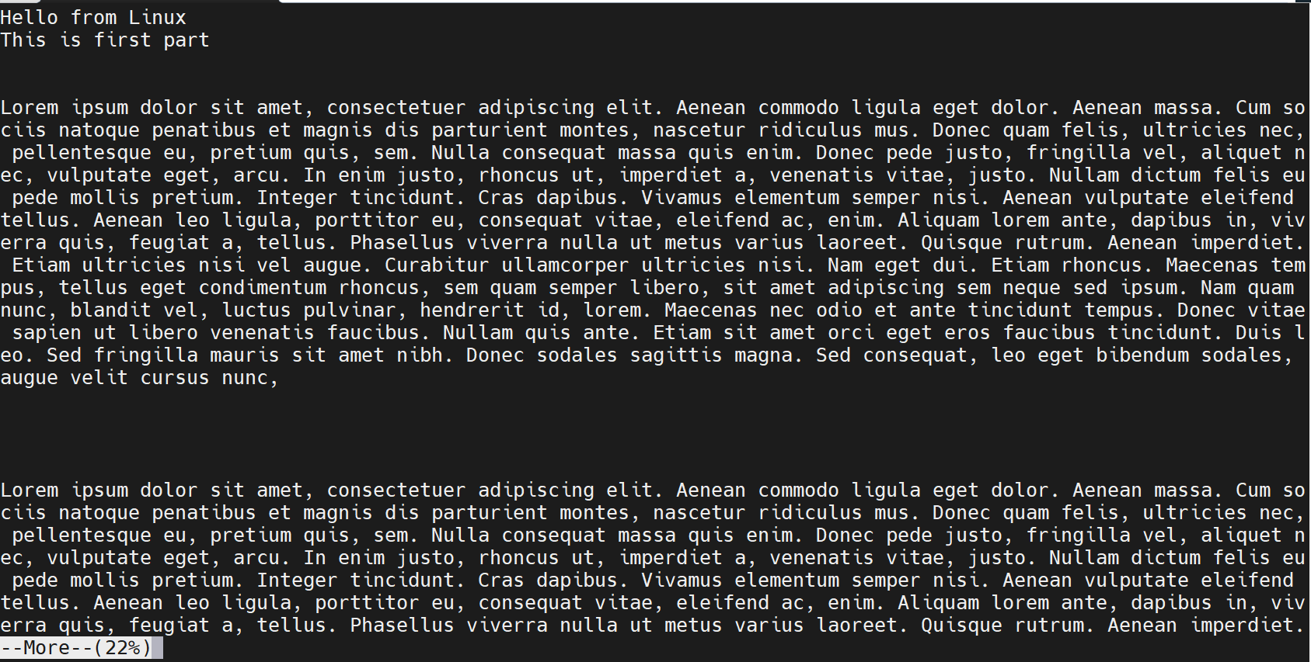

* head -<no_of_lines> <filename> = output of the first number of lines mentioned of the file

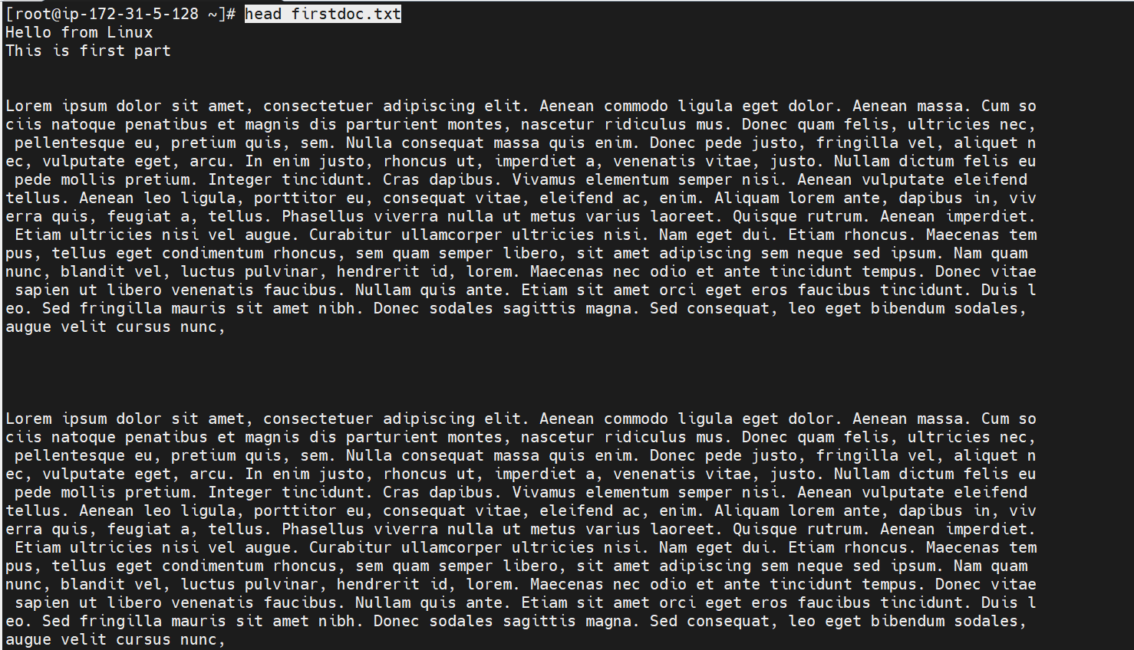

* tail -<no_of_lines> <filename> = If you want to display output of only last number of lines mentioned

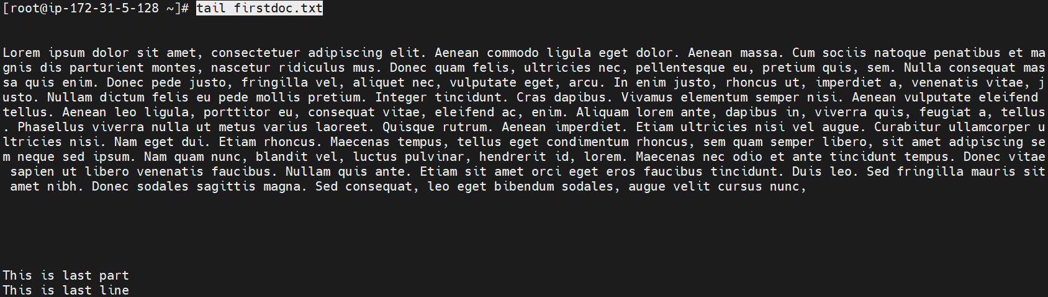

* touch <filename> = create a 0 bytes file

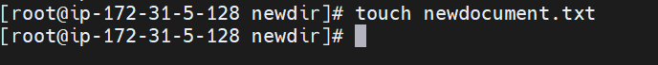

* cat > <filename> = create a file and allows to write



* nano <filename> = Creates a file if file name doesn’t exist and if already exits, continues editing the same

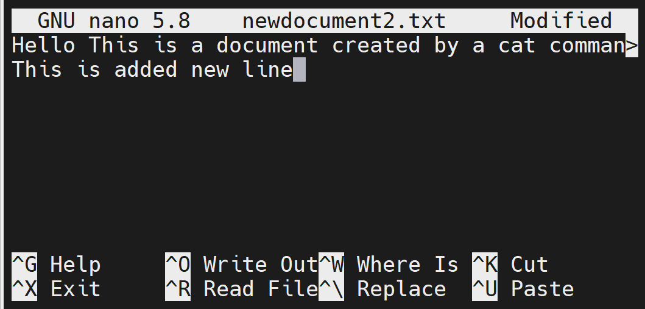

* vi <filename> = Creates a file if filename doesn’t exist and if already exits, continues editing the same

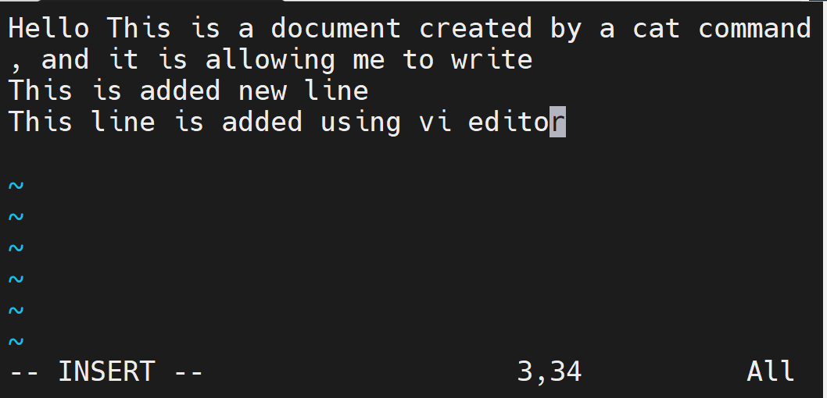

* rm <filename> = remove a file

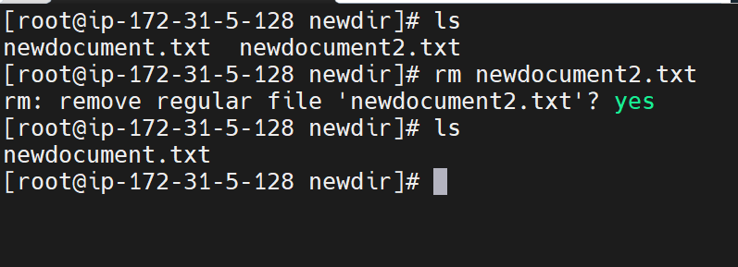

* mkdir <directoryname> = creates a directory

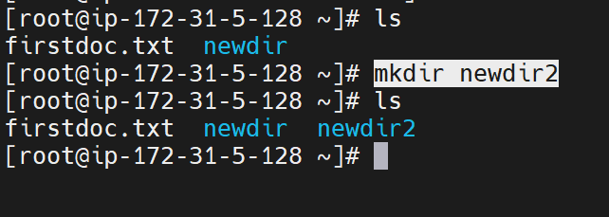

* rmdir <directoryname> = removes an empty directory

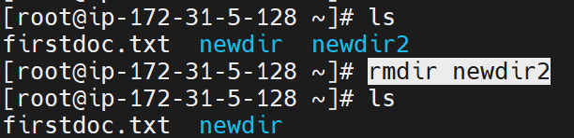

* rm -rf <directoryname> = removes a directory containing some files

